Government
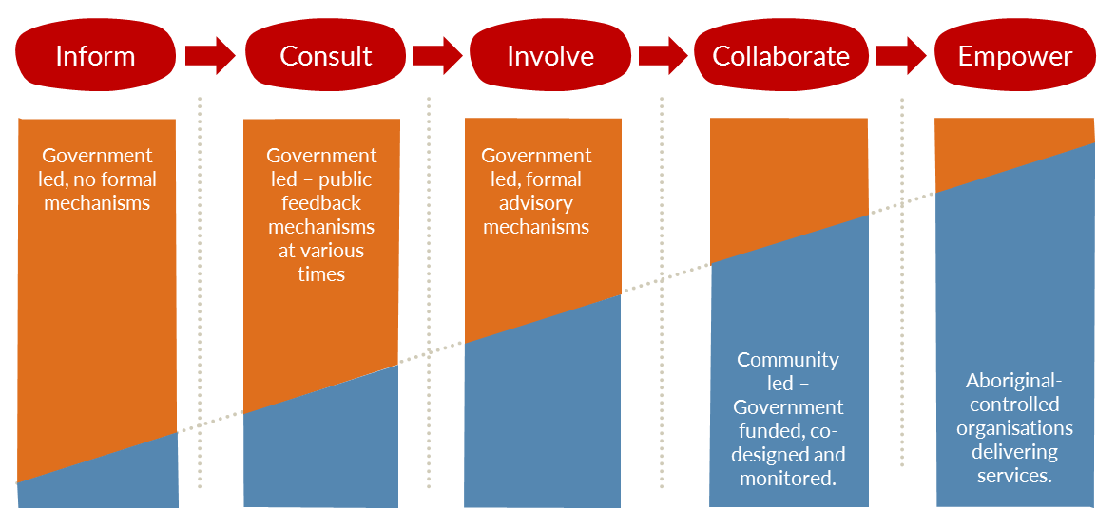

Community

Aboriginal communities can choose from a range of government services, and how much control they want for their communities.
Local Decision Making will provide a pathway for communities and Aboriginal organisations so they can take control of government services themselves. If Aboriginal Territorians want to have a greater say on how things are done in their communities, then they can work with government to develop a plan that suits them.
Some communities may already be on this journey while others will need to start from the beginning.
We will work together to help communities to fulfil their aspirations to move from ‘government led’ service delivery to ‘Aboriginal-controlled’ service delivery wherever possible.
It will be up to communities to tell government if they are interested and then start discussions about what can be done.
Call the Local Decision Making team to discuss your ideas and suggestions.

Contact
Director Local Decision Making – Robert (Bo) Carne
Email: DCM.LocalDescisionMaking@nt.gov.au

¹The Community Control Continuum is based on the principles of ‘International Association for Public Participation (IAP2) Public Participation Spectrum’

