**Preparing**

Community and government prepare to engage in the Local Decision Making process - understanding if they are ready to negotiate, what they might want to negotiate, how to engage, what’s in and what’s out,   
and to share meaningful information.

**Stage  
1**

**Becoming an   
Local Decision Making site**

The Local Decision Making project site and who will engage to represent community and government are confirmed. What is and is not on the table must be decided, and areas of specific interest identified, eg safe  
house and health clinic.   
and safe house.

**Stage  
2**

**Negotiating**

Formal negotiations start. Details such as level of community control and mechanism for transfer are agreed. A common purpose is reached.

**Stage  
3**

**Implementing**

Changes agreed during stage 3 are implemented, according to details agreed. This may include phased transfer of services and skills development, enabling community control of services.

**Stage  
4**

**Contact**

Director Local Decision Making – Robert (Bo) Carne

Email: [DCM.LocalDescisionMaking@nt.gov.au](mailto:DCM.LocalDescisionMaking@nt.gov.au)

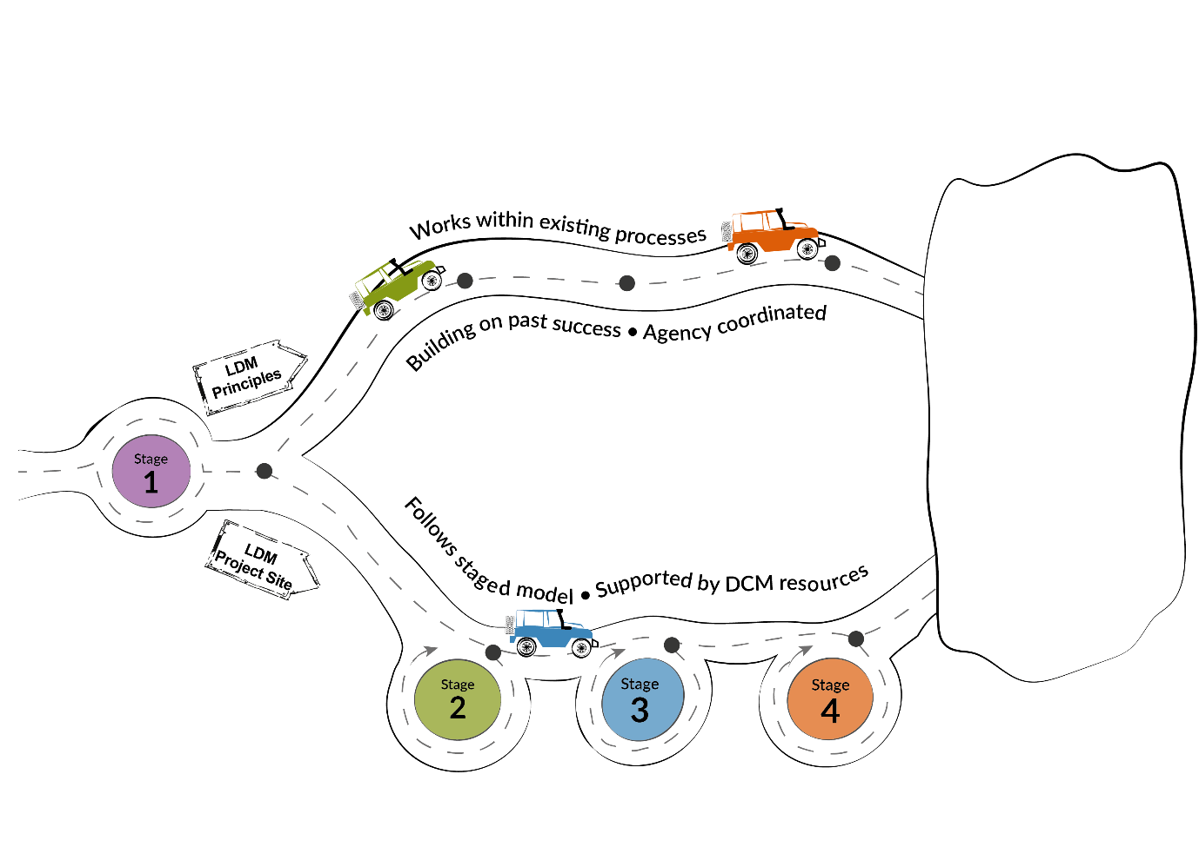

* Better health and   
  well-being outcomes for Aboriginal Territorians
* Improved economic outcomes for Aboriginal communities
* Stronger Aboriginal organisations
* Culturally appropriate government services
* More effective   
  service delivery
* Better relationships   
  with government