Community Plan Template

Purpose: For a community (through a representative body) to use to record what it would like to achieve through the LDM process.

When to use: Stage 2

Structure: A community representative body, such as a community organisation, fills in the template. They may choose to do this by themselves, or may request help from their government regional contact or another organisation or person. When they are ready, they share this with government, to help government understand what they would like to achieve through LDM.

Community and government can return to this plan to help guide decisions and stay on track throughout the process.

There is also a visual representation of this plan, a tree. If community would prefer to use this. This is available as an additional template together with this document. It could also be used as a visual communication tool when the representative group is reporting back to community about the plan.

If community would rather share their plan in a different way they can. The choice is up to the community and their representative body.

(Name of Community) Community Plan

About Our Community/Organisation

Our Vision for our Community

Our Governance Structure/Who represents us

Our Priorities for LDM

Community Control Scale: This scale shows the different levels of decision making. Some communities may want to run their own services whilst other may want to be more involved in the decision that are made about their community and policy. A community may start at Involve and over time as they develop their capacity to delivery and workforce may move to empower. Some communities may go straight to empower depending on their readiness.

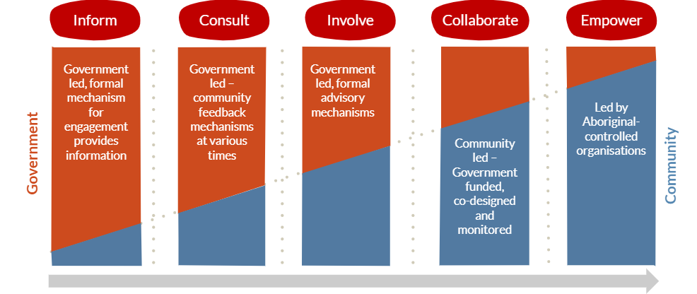

Example
Priority 1: Having more control and ownership over Housing

What we want to do: Run our own housing

Where would we like to be on the above table: Empower

What are things we want to start doing: Secure the housing maintenance contract to employ and train local people to deliver maintenance.

What areas do we need help with to achieve our goals?

Workforce Training, financial management training, more information about what housing is available and future plans in our community, bringing houses up to a good standard, a good relationship with Department of housing.

Priority 1:

What we want to do:

Where would we like to be on the above table:

What are things we want to start doing:

What areas do we need help with to achieve our goals?

Priority 2:

What we want to do:

Where would we like to be on the above table:

What are things we want to start doing:

What areas do we need help with to achieve our goals?

Priority 3:

What we want to do:

Where would we like to be on the above table:

What are things we want to start doing:

What areas do we need help with to achieve our goals?

