The Northern Territory Government is responsible for providing service delivery in communities. Local Decision Making means that Aboriginal communities can work together with government to make decisions and find solutions for service delivery that the Northern Territory Government has responsibility for.

Service delivery responsibilities include:
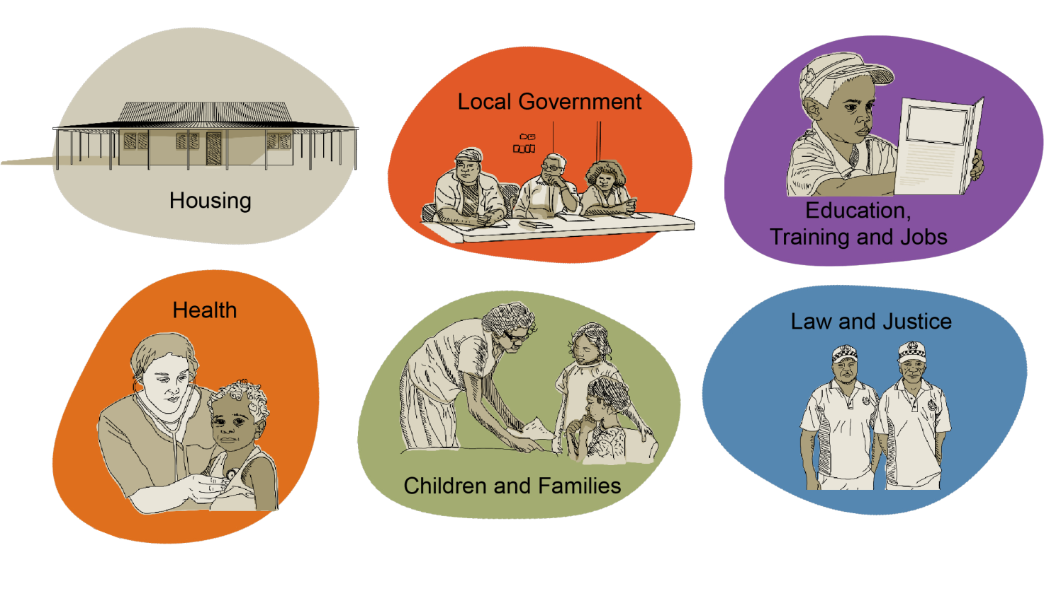
Some communities may want to focus on other services or programs such as:
- Sport and Recreation
- Youth Programs
- Women’s Programs
- Men’s Programs
- Land and Sea Management
- Business
Talk to us to discuss ideas and suggestions for your community.

Contact
Director Local Decision Making – Robert (Bo) Carne
Email: DCM.LocalDescisionMaking@nt.gov.au

