Preparing
Community and government prepare to engage in the Local Decision Making process - understanding if they are ready to negotiate, what they might want to negotiate, how to engage, what’s in and what’s out,
and to share meaningful information.

Stage
1
Becoming an
Local Decision Making site
The Local Decision Making project site and who will engage to represent community and government are confirmed. What is and is not on the table must be decided, and areas of specific interest identified, eg safe
house and health clinic.
and safe house.

Stage
2

Negotiating
Formal negotiations start. Details such as level of community control and mechanism for transfer are agreed. A common purpose is reached.

Stage
3
Implementing
Changes agreed during stage 3 are implemented, according to details agreed. This may include phased transfer of services and skills development, enabling community control of services.

Stage
4

Contact
Director Local Decision Making – Robert (Bo) Carne
Email: DCM.LocalDescisionMaking@nt.gov.au

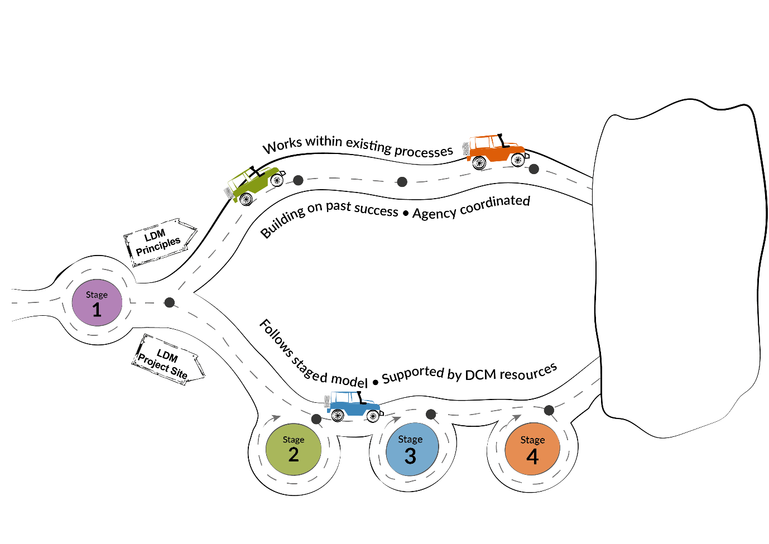
- Better health and
well-being outcomes for Aboriginal Territorians
- Improved economic outcomes for Aboriginal communities
- Stronger Aboriginal organisations
- Culturally appropriate government services
- More effective
service delivery
- Better relationships
with government

